**Ansible**

How to install ansible

Step 1:

Start application

To start the application first we need to create instances in AWS -ec2 instances

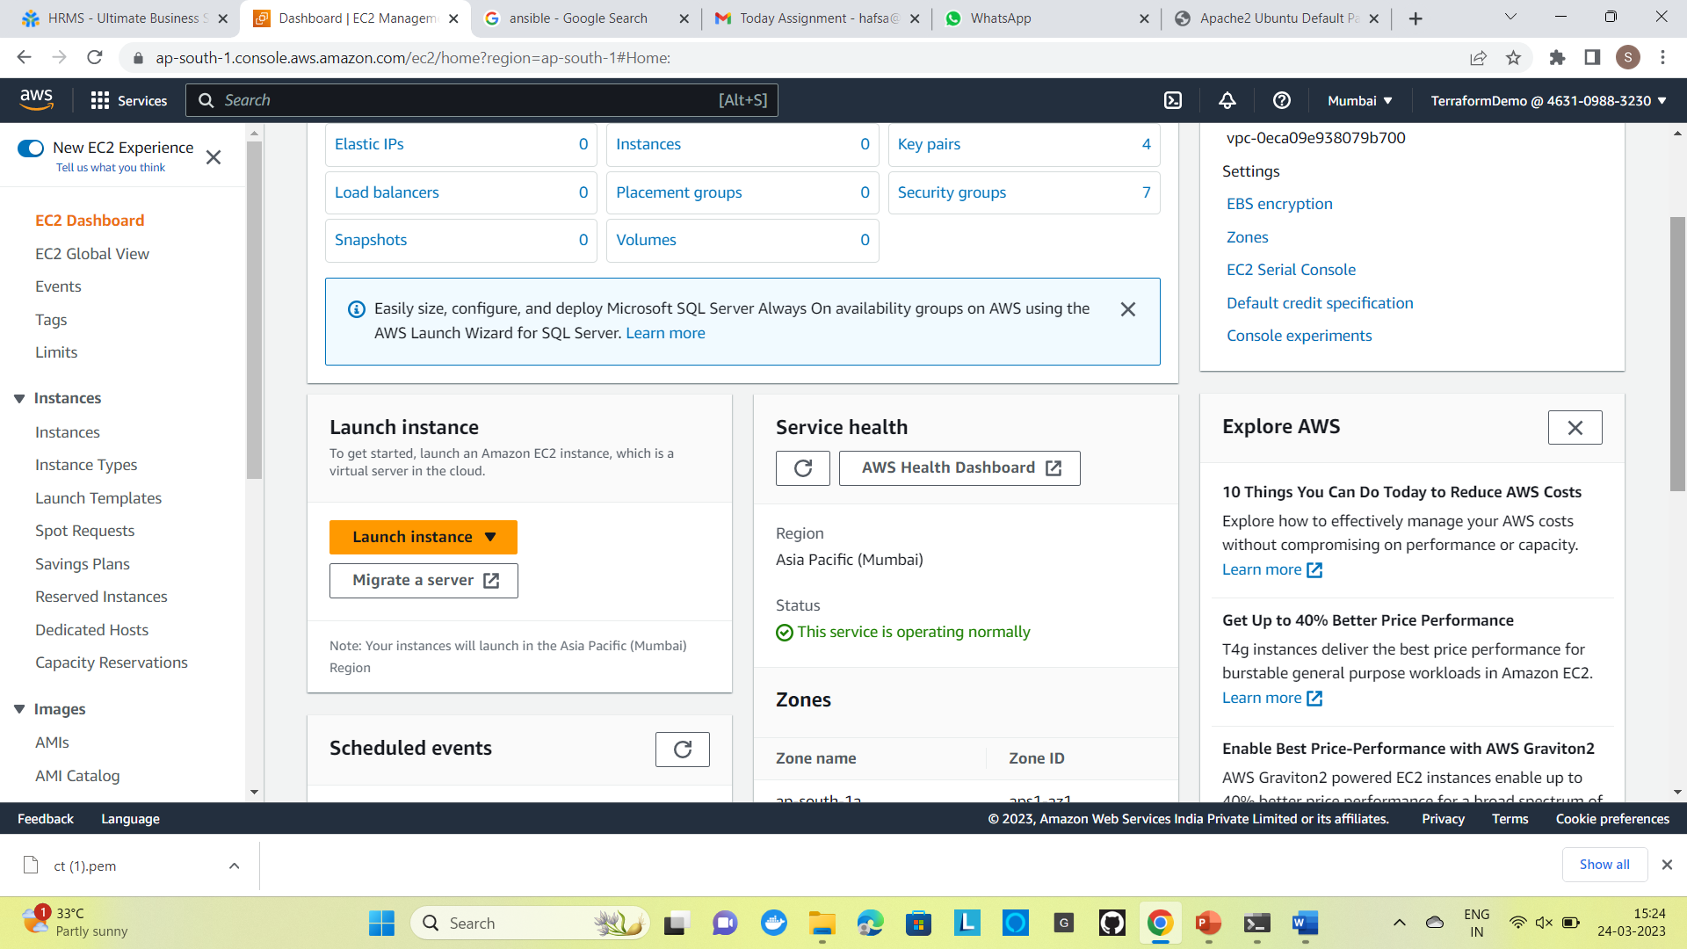

Step 2:

Create a instance and generate a new key pair

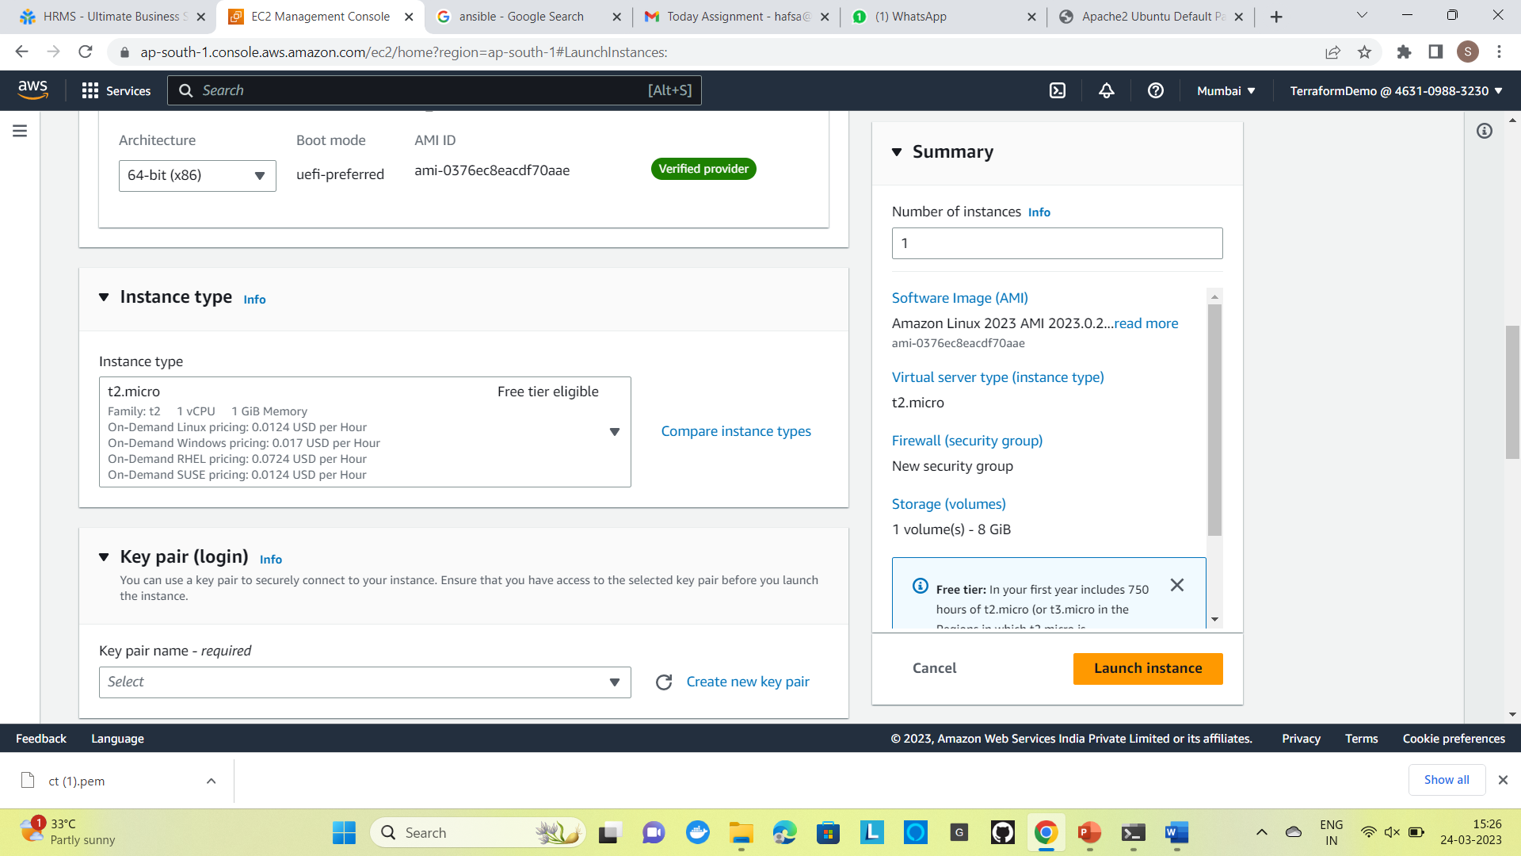

for example we create 4 instances

one master and 3 slave nodes 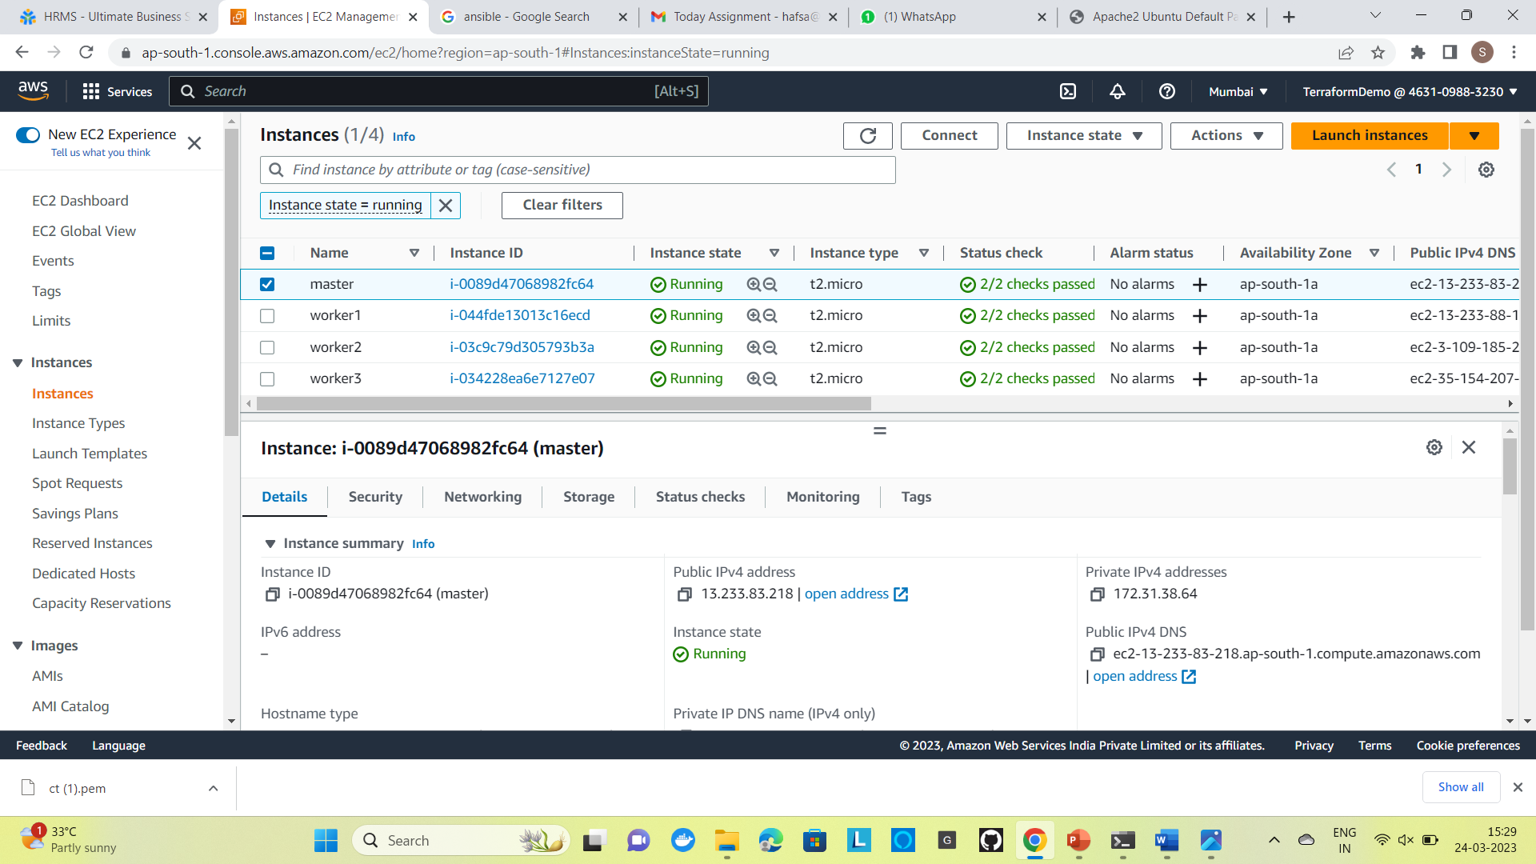

Step 3:

Connecting Master Node to Virtual server

while connecting it generates a ssh key

PS C:\Users\hafsa\downloads> scp -i .\"ct (1).pem" .\"ct (1).pem" ubuntu@ec2-13-233-83-218.ap-south-1.compute.amazonaws.com:~

ct (1).pem

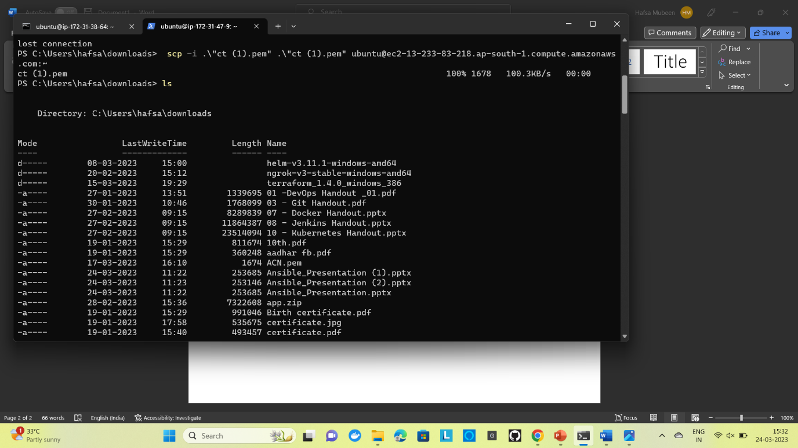

Step 4:

ubuntu@ip-172-31-38-64:~ $ cat /etc/issue

The command cat /etc/issue **may** provide some version information, but the main purpose of the /etc/issue file appears to be to provide a message which will be interpreted and printed by a getty-type program on the console.



Step 5:

ubuntu@ip-172-31-38-64:~$ sudo apt-add-repository ppa:ansible/ansible

**add-apt-repository** is a script which adds an external APT repository to either

/etc/apt/sources.list or a file in /etc/apt/sources.list.d/ or removes an already existing repository.

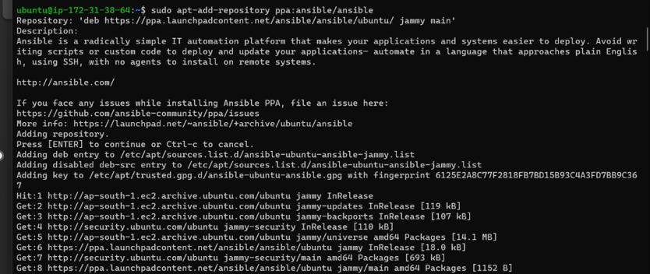

Step 6:

ubuntu@ip-172-31-38-64:~$ sudo apt update

The sudo apt-get upgrade command downloads and installs the updates for each outdated package and dependency on your system.

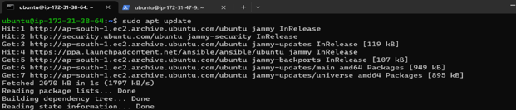

Step 7:

Open a new command prompt connect worker node 1 using ssh key

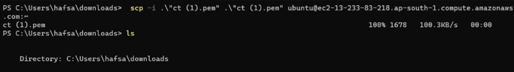

first command prompt and execute following commands

ubuntu@ip-172-31-38-64:~$pwd

The pwd command writes to standard output the full path name of your current directory (from the root directory)

Get Working Directory Path

ubuntu@ip-172-31-38-64:~$ls -l

It is used to list information about files and directories within the file system.

ubuntu@ip-172-31-38-64:~$chmod 400 ct\ \(1\).pem

It Gives the user read permission, and removes all other permission. It means to protect a file against the accidental overwriting, removing, renaming or moving files.

ubuntu@ip-172-31-38-64:~$ls

The ls command is used to list files or directories in Linux and other Unix-based operating systems.

ubuntu@ip-172-31-38-64:~$cat /etc/ansible/hosts

Ansible coming from Homebrew on OS X places the file in /usr/local/etc/ansible to allow regular user to modify the files without giving the account write permissions under the /etc branch.

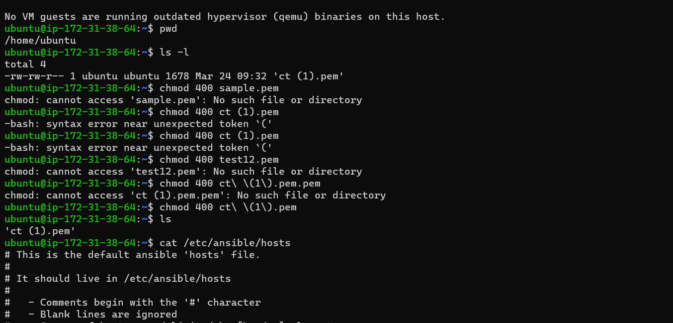

Step 8:

ubuntu@ip-172-31-38-64:~$sudo vi /etc/ansible/hosts

Ansible coming from Homebrew on OS X places the file in /usr/local/etc/ansible to allow regular user to modify the files without giving the account write permissions under the /etc branch.

Update the code in it

[webserver]

N1 ansible_host=ansible_user=ubuntu ansible_private_key_file=/home/ubuntu/ct (1).pem

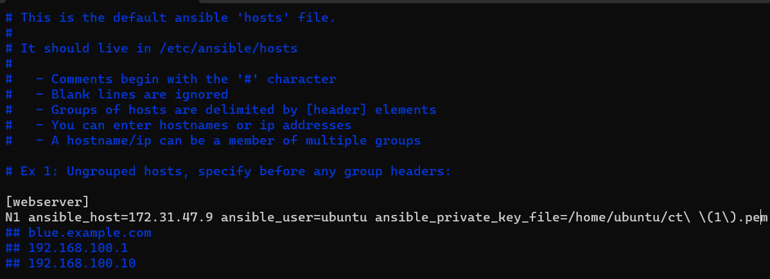

Step 9:

ubuntu@ip-172-31-38-64:~$ ansible all -m ping

The Ansible ping command tests the connectivity to the host to ensure that it can log in using the SSH key-based authentication.

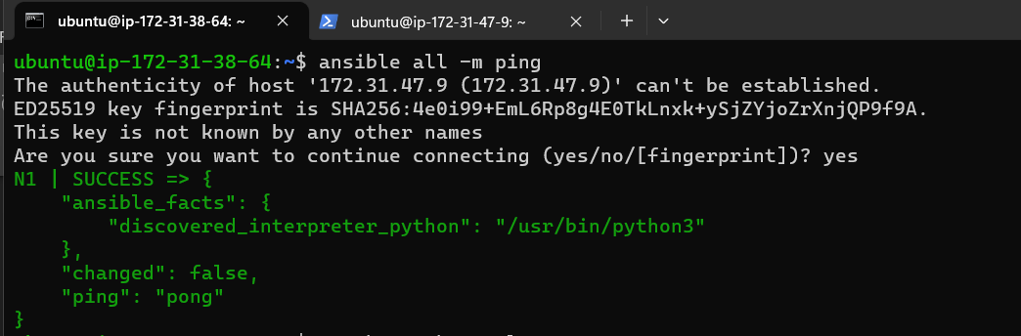

Step 10:

ubuntu@ip-172-31-38-64:~$ touch apache.yaml

Creates a new apache.yaml file

ubuntu@ip-172-31-38-64:~$ sudo vi apache.yaml

sudo permits an allowed user to execute a command as the superuser or another user, as determined in the sudoers document.



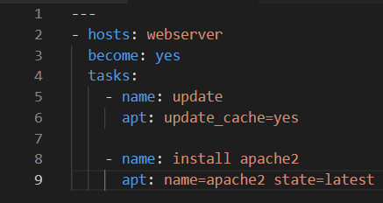

Step 10:

ubuntu@ip-172-31-47-9:~$ apache2 -v

Displays the version of apache installed

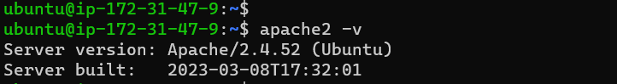

Step 11 :

ubuntu@ip-172-31-38-64:~$ ansible-playbook apache.yaml

Ansible Playbooks help IT staff program applications, services, server nodes, or other devices without the manual overhead of creating everything from scratch.

